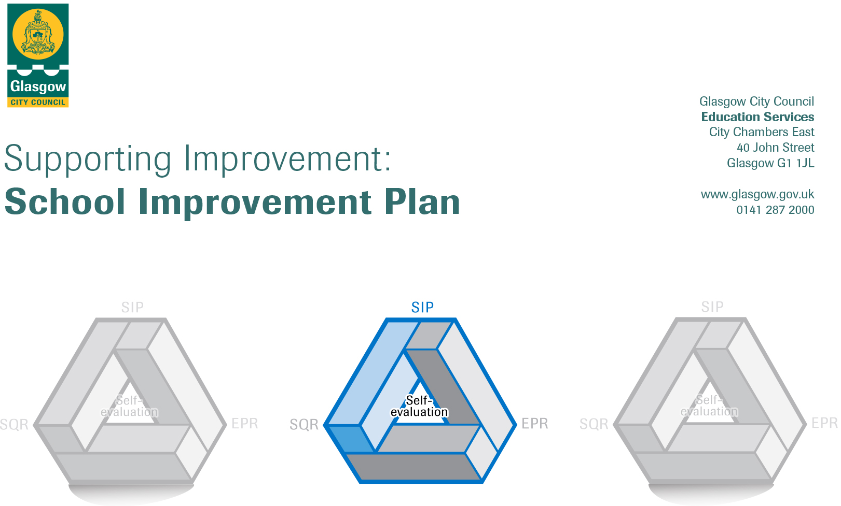

Establishment |  | Hamiltonhill Family Learning Centre
Head of Establishment |  | Frances Stokes
Area/Local Improvement Group |  | North East 2
Head of Service |  | Douglas Hutchison
Area ELC Manager |  | Alison Bowers

CONTENTS
1. Vision, Values and Aims
2. Summary of Self-Evaluation Process / Priorities for Improvement in the current session
3. Action Planning

Action Plan Summary for Stakeholders

1. Our Vision, Values and Aims
Hamiltonhill Family Learning Centre promotes positive partnerships between the home, nursery and the community, working together to meet the needs, and respect the rights, of all users. We ensure that all of the children are safe, healthy, achieving, nurtured, active, respected, responsible and included.

The family lies at the heart of the Centre’s vision, and relationships emphasis mutual trust and respect. In a positive and welcoming environment, we aim to support the whole family to build confidence and self-esteem.

Practitioners, children and parents or carers are encouraged to actively contribute to the life of the centre by working together to develop a community where:

• Everyone has the opportunity to develop to their full potential
• Diversity is celebrated, inequalities are reduced, and achievement is raised
• Children become confident individuals, successful learners, effective contributors and responsible citizens

2. Summary of our self-evaluation process.
Ongoing self-evaluation, using How good is our Early Learning and Childcare Curriculum and assessment materials
Practitioners consultation on In-Service days/Individual Room meetings Monitoring of attendance
Using strengths highlighted during practitioner’s PRD’s Children, parent/carer and practitioners’ questionnaires
Parent/Carer’s meetings Children’s journals and feedback from children, parents and carer’s
Inspection feedback Monitoring of establishment Improvement Plan
Children’s conversations Learning Community Moderation sessions
Stakeholders’ comments Digital Learning
Monitoring of playrooms Standards and Quality report
Peer and self-assessment LIG meetings/ discussions
National Care Standards
Strengths identified:

The head of centre promotes a clear vision that’s supports practitioners to develop meaningful aspirations for children and families. The head of centre has a comprehensive understanding of the importance of using the views of the children and families as well as partners to inform planning and development of the service. The Senior leadership team are very effective at supporting, motivating and responding positively to suggestions and practitioners’ requests. Distributed leadership is encouraged throughout the centre to support practitioners who are keen to undertake additional responsibilities and further qualifications. Some of the practitioners are currently undertaking the BA Childhood Practice, they are supported and mentored by the SLT. To further increase their skills and knowledge the practitioners regularly attend various training courses and twilight sessions. These training events have been important for practitioners to maintain their continuous personal development.

The children are happy, secure and settled in the centre, and the majority of them are making good progress in all aspects of their development and learning. The children are motivated and actively involved in their own learning. They plan learning experiences and make decisions about what they will learn about. Most of the children are making good progress, and can confidently recall and discuss what they have been learning about, and what they have learned.

Children are familiar with the environment, routine and experience warmth, kindness and respect from practitioners, there are nurturing relationships between children, practitioners and their peers throughout each playroom, based on respect. This enables children to feel cared for and safe.
To keep parents and carers up to date with, and involved in their children’s learning, information sessions and curriculum evenings are held regularly throughout the year. All of the children have Individual online learning profiles, and where required, Support Plans or Wellbeing Assessments and Plans, which the children, parents and carers can access at any time.

Priority 1: Raising children’s Attainment through Numeracy
The Lead Practitioner of Attainment attended year 2 of the Glasgow Counts training. The LPA met with the SLT, and keyworkers to discuss outcomes for this year and identifying the target group of children. Throughout the year the LPA had moderation meetings with keyworkers to discuss the target group’s progress and areas of development.

There were 2 identified outcomes this year, Outcome 1 – To ensure that for the targeted group of children, attainment of the early level tracker 1, page 1, increases by at least 40% by June 2023. Outcome 2 – To ensure that for a targeted group of children, attainment of early level tracker 1, page 2, increases by at least 40% by June 2023. The LPA worked with the targeted groups of children in small groups indoors and outdoors. She also worked alongside practitioners focusing on digital enhancements, mathematical stories and block play. Numeracy rich routines have been sustained and used as everyday opportunities to develop early mathematical skills. The LPA tracked children’s learning using the Early Level Numeracy Tracker 1 pages 1 and 2. The Leuven Scale was also used as a supporting tool to measure involvement. Practitioners tracked all children’s learning using the ‘Glasgow Counts’ trackers at the beginning, middle and end of year and met with the LPA to moderate children’s progress. The LPA attended ‘Glasgow Counts’ training which was then shared with practitioners at twilights as well as on a one to one basis. The LPA worked closely with the numeracy champion, coaching and modelling experiences that could be carried out with all children. All practitioners were issued a questionnaire in relation to training and support they have received and the impact this has had on their practice. The results gathered suggest that almost all practitioners found the one to one training very beneficial to them and their confidence levels increased whilst providing high quality numeracy experiences for children relating to page 2 of the numeracy tracker.

The LPA planned and implemented stay, play and learning sessions to engage parents and carers. These sessions have been a success, the majority of parents have attended and the feedback has been very positive, with parents recording their experience and how they have found the sessions on our feedback flipchart. The LPA introduced these sessions with the children and families in the 2-3 playroom this year which has also had a positive impact on families. The LPA arranged the cyber-tots programme, where practitioners, children and families attended the Library in block sessions throughout the year. This programme provided children with opportunities to develop their literacy and numeracy skills through digital and mathematical storytelling sessions. Children had access to computers for planned digital learning experiences. We are now seeing good family engagement during these sessions, as parents and carers have joined in and have given positive feedback.

The LPA was successful in achieving the identified outcomes with all the children in the target groups not only raising attainment by 40%, but exceeding this with most children making an average increase of 67% of outcome 1 and with some children making an increase as much as 91% progress. In outcome 2 most children made an average increase of 85% with some children making an increase of 100% progress.

Priority 2: Digital Strategy
We carried forward the Centre’s Digital strategy by further developing parental engagement, a continuation of further developing Seesaw in the 0-3 playrooms and staff continuous professional development in digital learning. The team leader met with practitioners from each playroom to discuss how we planned to use Seesaw across all playrooms and gathered the practitioner’s views about the process. The planning process and format was further developed in order to have a more consistent and streamlined approach to plan for all learners. The views gathered from practitioners via questionnaires, also identified that most practitioners feel planning and implementing learning for children has significantly improved using the digital platform “Seesaw”, however some practitioners have highlighted the need for more I-pads specifically in the 0-3 playrooms. We have also introduced assessment approaches on seesaw within the 3-5 playrooms, with the aim of this year to be embedded across all playrooms.
We gathered parental views on how they have found using seesaw. 41% of parents and carers responded, with all parents and carers responding positively to using seesaw. Parents comments included, “It’s great, it’s really good to see pictures and videos on a regular basis” “easy to use, engaging and fun”. It was also identified that of all methods of communication used, seesaw was the most popular amongst parents and cares.
Practitioners had the opportunity to meet on a one to one basis with the team leader to evaluate their planning and assessment using seesaw and also received support where required.

Priority 3: Language and Communication Friendly Nursery Accreditation

This year we aimed to become Language and Communication Friendly Accredited, however due to various barriers we were unable to achieve this. In August, practitioners met to evaluate the practice within the centre using the Self-evaluation toolkit and looked over the LCFA indicators. The working group that was created met to discuss the action plan and set the aims to be achieved.
In January 2023 we created a new playroom which supported the need for 2-3-year-old places, due to this we had to restructure our staffing which then had an impact on the progress of our priority of earning our accreditation. We also had to restructure our senior leadership team as one of our team leaders was redeployed to another establishment. These changes had an impact on our LCFE working party, which had to then be re-established. There were also changes to the language and communication coaches and mentors, we are now on our third mentor which had an impact on us progressing with the accreditation. However, we continue to strive towards achieving this. We have developed a new LCFE working group. We have also met with our new mentor who has visited the centre and who will provide training for practitioners in August 2023.

Priorities for development:
1: Practitioners will enhance their knowledge and skills of the moderation cycle through the moderation of STEAM with other establishments in the Learning Community
2: High quality planned learning will be achieved for all learners using See Saw
3: The Centre will achieve the LFCA

3. Action Planning

No. | Quality Indicator | Priority – (This should be a measurable outcome)
1 | 2.2 2.3 | Practitioners will enhance their knowledge and skills of the moderation cycle through the moderation of STEAM with other establishments in the Learning Community

Tasks/Interventions to achieve priority | Practitioners leading on this priority – including partners | Timescale/  Checkpoints | Success Criteria – What do you predict will be the impact on learners?  (Data, observation, views)
- Learning community core groups to meet to discuss action plan. | Practitioners, Hoc &LPA | Aug – Sept 2023 | Action plan will be created, all establishments to have a clear focus - Minutes of meeting, Action Plan,
- Practitioners will focus on science as an aspect of the moderation cycle. | Poppy room team | Oct 2023 | Seesaw will show the various science experiences planned and implemented using the moderation cycle. Practitioners will then participate in peer assessment and moderation. (Photographs, observations, seesaw posts, practitioner questionnaires)
- Visits to other early years establishments | Poppy room team & LPA | Nov 2023 | Practitioners will visit other establishment and record new ways to plan for STEAM, share good practice. (practitioners’ comments, observations, photographs)
- Practitioners and SLT will attend focus workshops within the learning community | Practitioners, LPA & HOC | Feb 2024 | Practitioners will participate in the workshops, learning new ways to plan for STEAM activities Share practice within the learning community (practitioners’ comments, observations)
- Practitioners will focus on technology as an aspect of the moderation cycle | Poppy room team | April 2024 | Seesaw will show the various Technology experiences planned and implemented using the moderation cycle. Practitioners will then participate in peer assessment and moderation (Photographs, observations, seesaw posts)
- Learning community showcase | Poppy room team, LPA & HOC | Jun 2024 | Our practitioners’ team will share new and exciting ways to plan and implement science and technology experiences for children with our colleagues in the learning community. Practitioners will also learn from the other experiences showcased. (Practitioners questionnaires, planned learning experiences, observations.)

Looking Forwards - Next Steps
(Not to be completed until priority achieved)

No. | Quality Indicator | Priority – (This should be a measurable outcome)
2 | 1.3 2.3 2.4 2.5 2.7 3.2 | High quality planned learning will be achieved for all learners using See Saw

Tasks/Interventions to achieve priority | Practitioners leading on this priority – including partners | Timescale/  Checkpoints | Success Criteria – What do you predict will be the impact on learners?  (Data, observation, views)
- SLT will ensure there is a clear and consistent planning and assessment approach for all learners using seesaw | SLT & Practitioners | Aug – Sept 2023 | All learners will engage in high quality planning and assessment. (Seesaw, observations, area plans, minutes of staff meetings parental views and questionnaires.)
- Purchase more teacher i-pads for practitioners | SLT | Aug – Oct 2023 | Practitioners will have easier and consistent access to seesaw and will have suitable resources to complete online learning journals for all children. (Regular posts on seesaw)
- One to one support sessions and twilight training for all practitioners | SLT & practitioners | Aug 2023 – June 2024 | Practitioners will have increased knowledge of curriculum planning and assessment. Practitioners will have the skills and feel more confident in planning using seesaw. (observations, staff questionnaires, monitoring of planning)
- Monthly room practitioners’ meetings | TL, LPA & practitioners | Monthly 2023 – 2024 | Practitioners will be more informed, enabling them to plan and implement quality learning experiences. SLT will be fully informed and involved in all children’s progress. (minutes of meeting, tracking children’s learning)
- Monitor use of seesaw and curriculum planning | SLT | Termly 2023 -2024 | SLT will support practitioners where required, practitioners will be fully supported in the planning and implementation for children’s learning and development. Staff will feel valued in their role. (monitoring documents, practitioner views)
- Evaluations produced using QR codes and online links for practitioners and parental questionnaires | SLT | November 2023 & May 2024 | Evidence will be gathered on staff, parental and carer’s views, this will be used to further develop our online journals and or method of gathering views. This will enable us to continue to improve practice. (parental, carer and practitioner questionnaires)

Looking Forwards - Next Steps
(Not to be completed until priority achieved)

No. | Quality Indicator | Priority – (This should be a measurable outcome)
3 | 1.1 1.3 1.5 2.4  3.1 3.2 | The Centre will achieve Language and Communication Friendly Accreditation

Tasks/Interventions to achieve priority | Practitioners leading on this priority – including partners | Timescale/  Checkpoints | Success Criteria – What do you predict will be the impact on learners?  (Data, observation, views)
- Establish a working group, meet with new mentor | HOC, TL & practitioners | July 2023 – Aug 2024 | Working group established, practitioner from each playroom and Head of Centre and Team Leader to join group to ensure sustainability of group. (minutes of meeting)
- Complete next steps identified in key indicator 1 | Working group, all practitioners | July 2023 – Aug 2023 | Key indicator 1 completed by each playroom, clear understanding of next steps, the next steps will be completed within each playroom. (self-evaluation toolkit completed for indicator 1, observations, practitioner)
- Attend training for Talk Strategies | Mentor, all practitioners & SLT | Aug 2023 | SLT and all practitioners are trained in Talk Strategies. (Practitioner views, training record,)
- Complete and implement next steps identified from priority indicators two, three, four and five | All practitioners | Aug 2023 – Jan 2024 | Key indicator 2,3,4 &5 completed by each playroom, clear understanding of next steps, the next steps will be completed within each playroom. (self-evaluation toolkit completed for indicator 2,3,4, & 5, observations, practitioner, peer assessment and moderation)
- Arrange meetings with working group and feedback from mentor | Working group | Aug 2023 – Jan 2024 | Regular communication with mentor, set achievable goals and timescales to complete the self-evaluation toolkit of indicators 2,3,4 & 5, monthly meetings with working group to discuss progress and next steps. (minutes of meetings, self-evaluation toolkit)
- Achieve accreditation and sustain good practice | All practitioners | Jan 2024 – June 2024 | The centre will achieve the LCFA. Continuous monitoring of indicators to sustain good practice. (minutes of meetings, self-evaluation toolkit, observations)

Looking Forwards - Next Steps
(Not to be completed until priority achieved)

