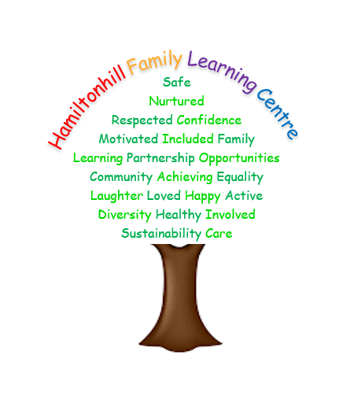

Hamiltonhill Family

Learning Centre

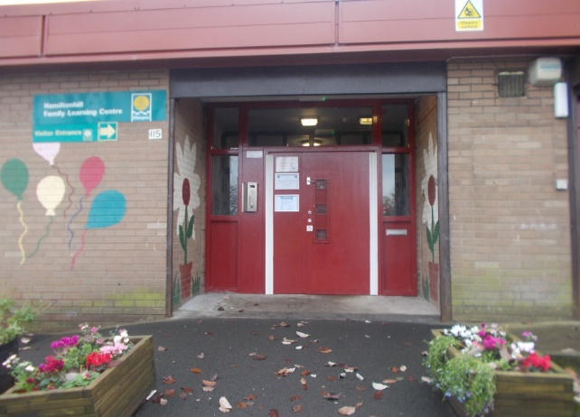

Handbook

2024/2025

115 Ellesmere Street

Glasgow G22 5QT

Tel: 0141 332 2797

Fax: 0141 332 2797

Email: [headteacher@hamiltonhill-nursery.glasgow.sch.uk](mailto:headteacher@hamiltonhill-nursery.glasgow.sch.uk)

Website: <http://www.hamiltonhill-nursery.glasgow.sch.uk/>

**CONTENTS**

**Section 1 - Establishment Aims**

Introduction

Vision, Values and Aims Statement

**Section 2 - General Information**

Names and job titles of our staff team

Establishment Hours of opening

Enrolment

Attendance

Clothing

Meals

The Establishment Year

Information in emergencies

**Section 3 - Medical Information**

Medical and Health Care

What if your child is ill?

Child Welfare and Safety

Oral Health

**Section 4 - Nursery Curriculum**

Curriculum for Excellence

Language and Communication Friendly Establishment

Scotland’s National Performance Framework

Social, Moral and Cultural Values

Child Protection Procedures

Equal Opportunities and Social Inclusion

Additional Support Needs/Accessibility Strategy

**Section 5 – Parental Partnership**

Curriculum, Assessment and Arrangements for Reporting

to Parents and Carers

The Keyworker System

Home and Establishment Links

Promoting Positive Behaviour

**Section 6 – Other Information**

No Smoking Policy

Data Protection Act 1998

The Freedom of Information (Scotland) Act 2002

Dealing with Racial Harassment

Comments and complaints

Addresses and Contacts

**Section 1 - Establishment Aims**

Introduction

Hamiltonhill Family Learning Centre is situated in the North East of Glasgow, and is in St Roch’s Learning Community. We provide early learning and childcare provision for children aged 3 months until 5 years.The centre is in Hamiltonhill, which lies on the outskirts of Possilpark. The local primary schools are Saracen, St. Teresa’s, St Cuthbert’s and Highpark.The centre is inspected by HMIe (Education Scotland) and Care Inspectorate.

**Vision, Values and Aims**

Hamiltonhill Family Learning Centre promotes positive partnerships between the home, nursery and the community, working together to meet the needs, and respect the rights, of all users. We ensure that all of the children are safe, healthy, achieving, nurtured, active, respected, responsible and included.  
The family lies at the heart of the centre’s vision, and relationships emphasise mutual trust and respect. In a positive and welcoming environment, we aim to support the whole family to build confidence and self-esteem.  
  
Staff, children and parents or carers are encouraged to actively contribute to the life of the centre by working together to develop a community where:

* Everyone has the opportunity to develop to their full potential
* Diversity is celebrated, inequalities are reduced, and achievement is raised
* Children become confident individuals, successful learners, effective contributors and responsible citizens.

Overall Aims and Objectives

* to promote equal opportunity
* to ensure a welcoming and positive ethos
* to ensure that all children have opportunities which enable them to reach their full potential.
* to work in partnership with children, parents, carers and other agencies.
* to support the emotional, social and physical well-being of children and their families.
* to provide support to meet the individual needs of young children and their families.

**Section 2 - General Information**

**Establishment Staff**

|  |  |  |
| --- | --- | --- |
| Frances | Stokes | Head of Centre |
| Lorraine | Gray | Depute Head of Centre |
| Natalie | Cassidy | Team Leader |
| Jacqueline | Bambridge | Lead Practitioner of Attainment |
| Angela | Robertson | Child Development Officer |
| Jemma | Pender | Child Development Officer |
| Natalie | Daniels | Child Development Officer |
| Kathleen | Welsh | Child Development Officer |
| Megan | McGeady | Child Development Officer |
| Sarahanne | Stewart | Child Development Officer |
| Kellyanne | Doyle | Child Development Officer |
| Charlene | Gallie | Child Development Officer |
| Caryn | Booth | Child Development Officer |
| Morgan | McElwain | Child Development Officer |
| Heather | Lawson | Child Development Office |
| Olivia | Haig | Child Development Officer |
| Nicola | MacDonald | Child Development Officer |
| Melanie | White | Child Development Officer |
| Noreen | Ahmed | Child Development Officer |
| Tracy | Donnelly | Child Development Officer |
| Mandy | Brothers | Child Development Officer |
| Melissa | Stark | Child Development Officer |
| Thomas | Cairns | Child Development Officer |
| Laura | Brown | Child Development Officer |
| Clare | Smillie | Child Development Officer |
| Lynne | McSherry | Child Development Officer |
| Graham | Stephen | Child Development Officer |
| Lorraine | Rankin | Clerical Support |
| Leanne | Lovie | Janitor |
| Lynsey | Casey | Catering Assistant |
| Jacques | Bompete | Catering Assistant |
|  |  |  |

**Capacity**

Child Places: -

0 to 2-year-old places – 21

2 to 3-year-old places- 25

3 to 5-year-old places- 40

A maximum of 86 children can attend the setting at one time.

We offer both term time and 52-week places. 1140 hours is allocated in block sessions.

Places are allocated in full time and part time sessions.

Child places are allocated at the admissions panel.

Applications for a place can be made at any time at the centre and these will all be considered at an admissions panel meeting, during which places will be allocated using Glasgow City Council’s Admissions and Charging Policy for Early Years. Emergency admissions may be considered on a temporary basis, depending on circumstances and needs.

 Further details on the admission process can be found [here](http://www.hamiltonhill-nursery.glasgow.sch.uk/Websites/SchNurHamiltonhillFLC/UserFiles/file/Management%20Circular%203a.docx).

**Enrolment**

If a place has been allocated for your child. The Head of Centre will contact you to offer the place. If you accept the place a date and time will be arranged to come in to the nursery to visit and complete the necessary paper work. As part of the enrolment process the nursery arranges to visit you and your child at home. This is to promote building positive relationships with keyworker and your child in environment that they comfortable. After the home visit we will arrange for your child to begin to settle within the nursery. The settling in process is different for each child and family. We recommend that there is at least a two-week settling in time.

**Hours**

The centre is opened between the hours of 8.00am and 5.30pm. We are a 52 week establishment and we are closed only on statutory public holidays, in-service days, between Christmas and New Year and any other days identified by Glasgow City Council.

**Attendance at the Establishment**

Children should attend regularly to get maximum benefit from their place. We would kindly ask if you could phone the centre to let us know if your child is off for any reason just to keep us informed. Thank you.

**Clothing**

There are forms of dress which are unacceptable in the centre, such as items of clothing which:

* potentially encourage faction (such as football colours):
* could cause offence (such as anti-religious symbolism or political slogans);
* could cause health and safety difficulties such as loose fitting clothing

or dangling earrings

* carry advertising, particularly for alcohol or tobacco; and
* could be used to inflict damage on other children and young people, or to be used by others to do so.

We ask that a spare change of clothes is provided for your child. This can be held in the cloth bag provided at your child’s allocated peg. Names should be marked on all the child's belongings to prevent mistaken identity and suitable clothing should be worn to allow children to participate in all activities without fear of damage. Although staff endeavour to take care of your child's clothes etc., we are not insured for damage or loss.

**Meals**

Snack and lunch is provided within the centre. The menu for snack and lunch is available on our website or displayed within the nursery setting.

If your child has any dietary or allergy requirements please state this in the application/ enrolment form prior to your child starting. If your child has a dietary requirement a medical letter must be provided to enable the correct diet is followed and provided for your child. If your child is bottle feeding or starting the weaning process this can be supported and provided within the setting. The details will be discussed during the enrolment process.

**Establishment Holidays and In-Service Days 2024/25**

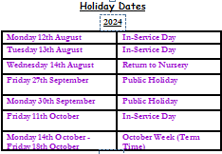

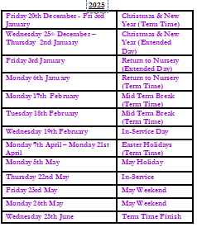

**Information in Emergencies**

We make every effort to maintain a full educational service, but on some occasions, circumstances arise which lead to disruption. Occasionally we may be affected by for example, severe weather, floods, power failures, or difficulties of fuel supply. In such cases we shall do all we can to let you know about the details of closure or re-opening.

**Section 3 - Medical Information**

**What if your Child is Ill?**

Children who have any possibly infectious illness should in the first instance feel free to ask for advice from the centre. When a diagnosis is made by your GP, we would ask that your child does not attend the centre until he/she has recovered.

Medication can be given to your child if prescribed by a doctor. This medication must be clearly labelled, and you are asked to give your child the first dose of any medicine. Parents must fill in a consent form for each course of treatment. If for any reason, your child is absent from nursery, please contact us to let us know. If your child becomes ill during their session at nursery, we will contact you, and you may be required to collect your child and seek medical advice. It is therefore extremely important that you keep us informed of any changes to your contact details.

**Child Welfare and Safety**

All educational establishments must take positive steps to help children protect themselves, by ensuring that programmes of health and personal safety are

central to the curriculum.

We must create and maintain a positive ethos and climate which actively promotes child welfare and a safe environment by:

* ensuring that children are respected and listened to;
* ensuring that programmes of health and personal safety are central to the curriculum;
* ensuring that staff are aware of child protection issues and procedures;
* establishing and maintaining close working relationships and arrangements with all other agencies to make sure that professionals collaborate effectively in protecting children.

Should any member of staff have concerns regarding the welfare or safety of any child they must report these concerns to the Head of Establishment, or the person deputising for the Head of Establishment. He/she after judging that there may be grounds for concern regarding the welfare or safety of any child, must then immediately advise the duty Senior Social Worker at the local Social Work Services

area office of the circumstances.

The community police, local library and road safety services regularly visit the centre to offer support and advice to the children, parents, carers and other users.

**Oral Health**

The Centre participates in the Oral Health project. Each child has their own toothbrush and toothpaste and is given one to take home. These are renewed regularly. All staff are trained annually for the’ Smile Too’ qualification which provides staff with information about tooth brushing and other activities for the children.

In order to promote good oral health, milk and water are the only drinks offered here, and we ask that parents avoid bringing sweets into the centre.

Dental inspections are carried out, as well as fluoride varnishing once a year. Your child will receive this when they are in their ante pre-school and pre-school year.

**Section 4 - Nursery Curriculum**

**Curriculum and Assessment**

All Glasgow City Council establishments adhere to the initiatives and guidelines as set by the Scottish Government and Glasgow City Council. For planning and assessment, the Curriculum for Excellence and the Pre-birth to Three Positive Outcomes for Scotland’s Children and Families are utilised for the benefit of every individual child.

Children begin their journey of learning from birth, and their first learning experiences are supported by their parents and family. This is why we feel that it is important to work in partnership with parents to provide your child with the appropriate high quality experiences to build on their learning and further their knowledge and understanding of the world around them. In this centre, opportunities are given for parents/carers to discuss any aspect of their child’s progress with staff and there are planned parents’ evenings during the year.

Children learn more effectively if they are interested in what they are doing. We therefore respond to their individual interests when planning from the curriculum. Initially, very young children, through early interactions and experiences, begin to find out about themselves, other people and the environment around them. They learn through exploring and using their senses, and with this in mind, we offer varied experiences such as, treasure basket, heuristic play and activities to develop their five senses. As they grow in confidence, children begin to try out and experiment with more challenging resources. To support these changes of needs, we plan a wide and varied curriculum, following the 8 Curricular areas as described in the *Curriculum for Excellence* document for the 3-5 age group, and the *Pre-birth to Three Positive Outcomes for Scotland’s Children and Families* document is now used to support the 0-3 age group concentrating on the under three’s key aspects. There is open access to these documents in the front foyer of the building.

**Language and Communication Friendly Establishment**

Language and Communication Friendly Accreditation

*"Our ability to use language lies at the centre of our development and the expression of our emotions, our thinking, our learning, and our sense of personal identity"*

*Curriculum for Excellence.*

We are working towards gaining the Language and Communication Friendly Establishment accreditation. We are working our way through and implementing the 5 key indicators to improve our practice, and best support the language and communication of all the children in our centre.

Talk Strategies

These are the Talk Strategies that we are working our way through and putting into practice. They are very useful strategies for you to try out at home and join us in improving the language that we use and the way that we communicate with children.

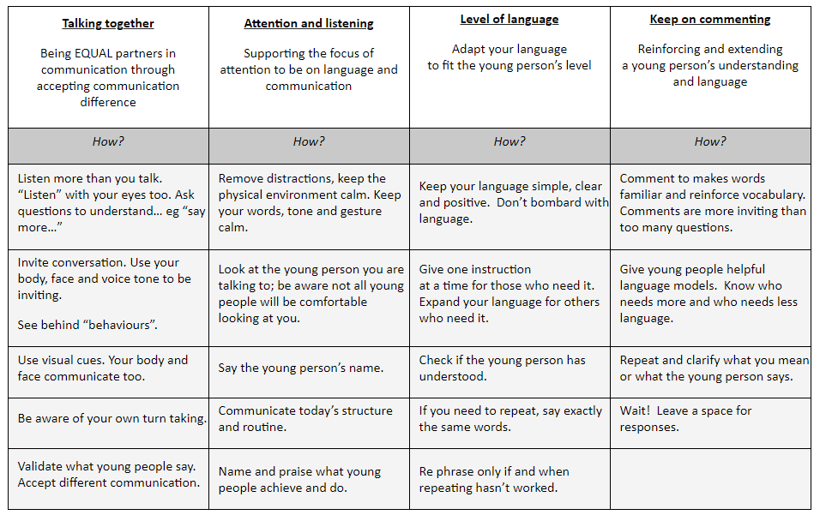

Please click [here](https://blogs.glowscotland.org.uk/glowblogs/glasgowpsychologicalservice/language-communication-friendly-environment/) to view the document.

**Scotland’s National Performance Framework**

The National Performance Framework is for all of Scotland. It sets out a vision for collective wellbeing. The National Outcomes tell us what good looks like. The national indicators help us to understand if we are moving in the right direction towards them. It supports a shared way of working. It asks everyone to work together to help to improve the lives of the people of Scotland.

**Social, Moral and Cultural Values**

We offer the children opportunities to take part in learning experiences designed to enable them to learn about and celebrate different festivals and cultures. We encourage the children to be honest and trustworthy, care for, and be respectful towards, others with the expectation that the children will become confident individuals with positive self-esteem.

**Equal Opportunities and Social Inclusion**

We aim to ensure that the children, parents, staff and other agencies are treated equally, with respect and without discrimination. We offer learning experiences through the curriculum to raise the children’s awareness of the differences in our world and we encourage them to treat others equally and to respond sensitively to their peers.

**Additional Support for Learning Accessibility Strategy**

We have a duty to ensure that all of our children have equal access to the curriculum, supported as appropriate to their individual needs. This covers not only the content of planned activities and teaching strategies but also minor adaptations to the physical environment of our building to address the needs of children with physical or sensory impairments. We also need to ensure that parents and carers who have a disability have equal access to information about their child. This will involve, for example, relocating the venue for parents/carers meetings to facilitate physical access; provision of an interpreter for people who have a hearing impairment; agreeing a phone contact system to provide direct feedback to parents and carers. The centre being on one level, has no stairs and has wheelchair access at all external doors. Throughout the year, staff have opportunities to take part in training such as, Makaton, Autism Awareness and Additional Support for Learning.

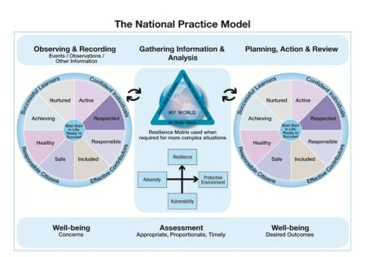

**Section 5 – Parental Partnership**

**Parental Involvement in the Curriculum**

We aim to work in partnership with families at all times. The first line of contact is your child's key worker who will work with you, and share information on a two-way basis to help your child benefit from the placement.

The Head of Centre, Depute Head of Centre and Child Development Team Leaders will also be available to offer support, advice and information.

**The Keyworker System**

The keyworker is responsible for a group of children. They are also responsible for building relationships with parents/carers. Over a period of time the keyworker can build up a clear picture of each child’s abilities and skills, and can plan learning experiences for each child to further develop these abilities and skills.

Keyworkers also have the responsibility for the learning environment to ensure children have an enriched learning environment which enables learning effectively through play.

Home

To

Nursery

**Home and Establishment Links**

We actively encourage parents and carers, children, staff and other agencies to become involved in the life of our centre. We aim to keep you up-to-date with all aspects of our provision, through home to nursery links, newsletters, daily contact, telephone calls, notices, parents’ meetings and children’s profiles. There is an open door policy and management are also very closely involved in the process. We appreciate any comments and suggestions from parents and carers, and their contributions help us in our self-evaluation process, which in turn leads to improvements within our practice.

**Promoting Positive Behaviour**

Good behaviour and positive relationships are very important in the centre. Our Promoting Positive Behaviour policy can be obtained, on request, from the office. Glasgow City Council’s policy can be found on www.glasgow.gov.uk.

We are exploring solution-orientated approaches to positive behaviour management. We do this within the centre, through curriculum work with the children, through discussions we have with them about how they feel, and their expectations about positive behaviour. We also do this through the opportunities we offer to parents, for example - Triple P, behaviour management courses, stress management classes, baby massage and other activities that support parent/carers. Hopefully these activities will enhance their relationship with their children.

**Section 6 – Other Information**

**No Smoking Policy**

We have a strict no smoking policy, smoking is not allowed in the building and on/near nursery grounds.

**Data Protection Act 1998**

Information on children and young people, parents and carers is stored on a computer system and may be used for teaching, registration, assessment and other administrative duties. The information is protected by the Data Protection Act 1998 and may only be disclosed in accordance with the Codes of Practice. For further information please contact the establishment.

**The Freedom of Information (Scotland) Act 2002**

The Freedom of Information (Scotland) Act 2002 enables any person to obtain

information from Scottish public authorities. The Act applies to all Scottish public authorities including - Scottish Government and its agencies, The Scottish Parliament, local authorities, NHS Scotland, universities and further education colleges, and the police.

Public authorities have to allow access to the following information:

* The provision, cost and standard of its service
* Factual information or decision-making
* The reasons for decisions made by it.

**Dealing with Racial Harassment**

The Race Relations Act of 1976 makes it unlawful to discriminate against someone because of his/her colour, race, nationality, ethnic or national background. The Act makes it the duty of Glasgow City Council to eliminate unlawful racial discrimination.

In 1999 the guidelines “*Dealing With Racial Harassment*” were issued to assist all teaching staff in dealing with such incidents. The adoption of an anti-racist approach should be seen as one part of the continuing attempt to improve the quality of education.

Glasgow City Council recognises that support from the home is essential if these aims are to be achieved. Every child in Glasgow has the right to be happy and secure at establishments.

**Bullying**

Bullying behaviour will not be tolerated within Glasgow City Council’s educational establishments. All children in Glasgow’s educational establishments have an entitlement *“to work (and play) in a learning environment in which they feel valued, respected and safe and are free from all forms of abuse, bullying or discrimination”*. (A Standard for Pastoral Care in Glasgow Establishments).

In 2009, Glasgow City Council published its revised Anti-Bullying Policy,

incorporating the requirement to record and report all discriminatory behaviours within educational establishments. All establishments are required to review their policy in light of this. Parents and carers have a significant role to play in helping to address this problem. For this reason any anti-bullying strategy must stress the importance of partnership with the parents and carers of their children.

**Privacy Statement**

Local authority schools and early year’s establishments process information about children and young people in order to provide education and care. In doing so we must comply with the Data Protection Act (1998). This means, amongst other things, that the data held about children, must only be used for specific purposes.

However, you should be aware that we may use this information for legitimate purposes, and may share this information where necessary, with other public bodies, or as otherwise required by law. We may also use any information for research purposes. However, all personal data is treated as confidential and used only in accordance with the Data Protection Act and with the Information Use and Privacy Policy approved by the City Council.

For further information please see our full privacy statement at [www.glasgow.gov.uk/uk/index.aspx?articleid=2895](http://www.glasgow.gov.uk/uk/index.aspx?articleid=2895)

**Comments and complaints**

If you have a comment or complaint, please approach the Head of Establishment in the first instance, who will investigate matters and report back to you within 5 days.

If the Head of Establishment does not resolve the issue to your satisfaction, you should contact our Customer Liaison Unit who will:

* Take a totally neutral stance in fully investigating your complaint;
* Acknowledge receipt of your complaint within five working days;
* Give a full written response within a further 10 working days, unless

another timescale has been agreed;

The Customer Liaison Unit can be contacted by phone or e-mail:

Phone 0141 287 5384

E-mail education@glasgow.gov.uk

Customer Liaison Unit

Education Services

Glasgow City Council

City Chambers East

40 John Street

GLASGOW

G1 1JL

Suggestions and complaints are always treated seriously, but if they are not handled to your satisfaction, there are forms available in the main office for you to officially make a complaint through either the Council's complaints procedure, or Social Care and Social Work Improvement Scotland.

Important Addresses and Contacts

Executive Director of Education

Maureen McKenna

Education Services

City Chambers East

40 John Street

GLASGOW

G1 1JL

MP:

Paul Sweeney (Labour)

Councillors:

[Allan](https://www.writetothem.com/write?who=42443&pc=G22+5QT&fyr_extref=https%3A%2F%2Fwww.mysociety.org%2Fcontact-your-local-councillor%2F%3Fgclid%3DCNXSzILUysICFYrHtAodogMAAg) Gow (SNP), [Gary](https://www.writetothem.com/write?who=56485&pc=G22+5QT&fyr_extref=https%3A%2F%2Fwww.mysociety.org%2Fcontact-your-local-councillor%2F%3Fgclid%3DCNXSzILUysICFYrHtAodogMAAg) Gray (Labour), [Jacqueline](https://www.writetothem.com/write?who=56521&pc=G22+5QT&fyr_extref=https%3A%2F%2Fwww.mysociety.org%2Fcontact-your-local-councillor%2F%3Fgclid%3DCNXSzILUysICFYrHtAodogMAAg) McLaren (SNP), [Robert](https://www.writetothem.com/write?who=42442&pc=G22+5QT&fyr_extref=https%3A%2F%2Fwww.mysociety.org%2Fcontact-your-local-councillor%2F%3Fgclid%3DCNXSzILUysICFYrHtAodogMAAg) Mooney (Labour)

MSPs:

Constituency MSP – Bob Doris (SNP) [bob.doris.msp@parliament.scot](mailto:bob.doris.msp@parliament.scot)

Regional MSPs – [Anas](https://www.writetothem.com/write?who=49443&pc=G22+5QT&fyr_extref=https%3A%2F%2Fwww.mysociety.org%2Fcontact-your-local-councillor%2F%3Fgclid%3DCNXSzILUysICFYrHtAodogMAAg) Sarwar (Labour), [Johann](https://www.writetothem.com/write?who=49488&pc=G22+5QT&fyr_extref=https%3A%2F%2Fwww.mysociety.org%2Fcontact-your-local-councillor%2F%3Fgclid%3DCNXSzILUysICFYrHtAodogMAAg) Lamont (Labour), [Adam](https://www.writetothem.com/write?who=49440&pc=G22+5QT&fyr_extref=https%3A%2F%2Fwww.mysociety.org%2Fcontact-your-local-councillor%2F%3Fgclid%3DCNXSzILUysICFYrHtAodogMAAg) Tomkins (Conservative), [Patrick](https://www.writetothem.com/write?who=49528&pc=G22+5QT&fyr_extref=https%3A%2F%2Fwww.mysociety.org%2Fcontact-your-local-councillor%2F%3Fgclid%3DCNXSzILUysICFYrHtAodogMAAg) Harvie (Green), [James](https://www.writetothem.com/write?who=49465&pc=G22+5QT&fyr_extref=https%3A%2F%2Fwww.mysociety.org%2Fcontact-your-local-councillor%2F%3Fgclid%3DCNXSzILUysICFYrHtAodogMAAg) Kelly (Labour), [Pauline](https://www.writetothem.com/write?who=49544&pc=G22+5QT&fyr_extref=https%3A%2F%2Fwww.mysociety.org%2Fcontact-your-local-councillor%2F%3Fgclid%3DCNXSzILUysICFYrHtAodogMAAg) McNeill (Labour) and [Annie](https://www.writetothem.com/write?who=49510&pc=G22+5QT&fyr_extref=https%3A%2F%2Fwww.mysociety.org%2Fcontact-your-local-councillor%2F%3Fgclid%3DCNXSzILUysICFYrHtAodogMAAg) Wells (Conservative)

Contact:

City Chambers

George Square

Glasgow

G2 1DU

0141 287 5604

**Surgery Details**:

**Allan Gow** – SNP (0141 287 4238) [allan.gow@glasgow.gov.uk](mailto:allan.gow@glasgow.gov.uk))

|  |  |  |  |
| --- | --- | --- | --- |
| 14/03/2018 | 6.30pm. | Lambhill Stables, 11 Canal Bank North, Glasgow, G22 6RD. |  |
| 10/04/2018 | 6.30pm. | Trinity Church, 1 Crowhill Street, Glasgow, G22 6SR. |  |
| 24/04/2018 | 6.30pm. | St Monica's Primary School, 200 Liddesdale Road, Glasgow, G22 7QX. |  |
| 03/05/2018 | 3.00pm. | Westercommon IT Suite, 45 Firhill Road, Glasgow, G20 7BE. |  |
| 09/05/2018 | 6.30pm. | Lambhill Stables, 11 Canal Bank North, Glasgow, G22 6RD. |  |
| 06/06/2018 | 6.00pm. | Ruchill Community Centre, 671 Bilsland Drive, Glasgow, G20 9NF. |  |
| 12/06/2018 | 6.30pm. | Trinity Church, 1 Crowhill Street, Glasgow, G22 6SR. |  |
| 26/06/2018 | 6.30pm. | St Monica's Primary School, 200 Liddesdale Road, Glasgow, G22 7QX. |  |
| 06/06/2017 | 6.00pm. | Ruchill Community Centre, 671 Bilsland Drive, Glasgow, G20 9NF. |  |

**Gary Gary** – Labour (0141 287 7041) [gary.gray@glasgow.gov.uk](mailto:gary.gray@glasgow.gov.uk),

|  |  |  |  |
| --- | --- | --- | --- |
| 1st Monday. | 6.00pm. | Henry Drummond Trinity Church, Crowhill Street. |  |
| 2nd Monday. | 5.00pm. | Possilpoint Community Centre, 130 Denmark Street. |  |
| 3rd Friday. | 3.00pm. | The Courtyard Office, 2 Westercommon Drive. |  |
| 4th Friday. | 3.00pm. | Hawthorn Housing Co-op Office, 23A Finlas Street |  |

**Jacqueline McLaren** – SNP (0141 287 0223) [jacqueline.mclaren@glasgow.gov.uk](mailto:jacqueline.mclaren@glasgow.gov.uk)

|  |  |  |  |
| --- | --- | --- | --- |
| 13/03/2018 | 6.30pm. | Trinity Church, 1 Crowhill Street. |  |
| 27/03/2018 | 6.30pm. | St Monica's Primary School, 200 Liddlesdale Road. |  |
| 02/04/2018 | 7.00pm. | Cadder Community Centre, 110 Tresta Road. |  |
| 05/04/2018 | 3.00pm. | Westercommon IT Suite, 45 Firhill Road. |  |
| 11/04/2018 | 6.30pm. | Lambhill Stables, 11 Canal Bank North. |  |
| 02/05/2018 | 6.00pm. | Ruchill Community Centre, 671 Bilsland Drive. |  |
| 08/05/2018 | 6.30pm. | Trinity Church, 1 Crowhill Street. |  |
| 29/05/2018 | 6.30pm. | St Monica's Primary School, 200 Liddlesdale Road. |  |
| 04/06/2018 | 7.00pm. | Cadder Community Centre, 110 Tresta Road. |  |
| 07/06/2018 | 3.00pm. | Westercommon IT Suite, 45 Firhill Road. |  |
| 13/06/2018 | 6.30pm. | Lambhill Stables, 11 Canal Bank North. |  |

**Robert Mooney** – Labour (0141 287 3934) [robert.mooney@glasgow.gov.uk](mailto:robert.mooney@glasgow.gov.uk)

|  |  |  |  |
| --- | --- | --- | --- |
| 1st Monday. | 4.15pm. | Ruchill Community Centre, 671 Bilsland Drive. |  |
| 2nd Monday. | 4.00pm. | Cadder Community Centre, 20 Fara Street. |  |
| 3rd Friday. | 4.00pm. | Ashgill Recreation Centre, 340-342 Ashgill Road. |  |
| 4th Friday. | 4.00pm. | St Monica's Primary School, 200 Liddesdale Road. |  |

Education Services

City Chambers East

40 John Street

GLASGOW

G1 1JL

0141 287 2000

**Map of surrounding area :** 115 Ellesmere Street, Possilpark, Glasgow, G22 5QT

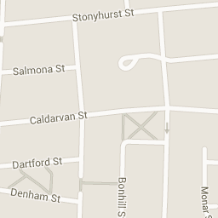

C:\Users\jb00101681\Pictures\hamiltonhill family learning centre - Google Maps_files\red_markers_A_J2.png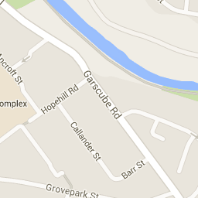

Although this information is correct at time of printing, there could be changes affecting any of the matters dealt with in the document:

1. before the commencement or during the course of the establishment year in question
2. In relation to subsequent establishment years

Frances Stokes, Head of Centre, will inform you of any important changes.